Exercise for Understanding Wave Anatomy

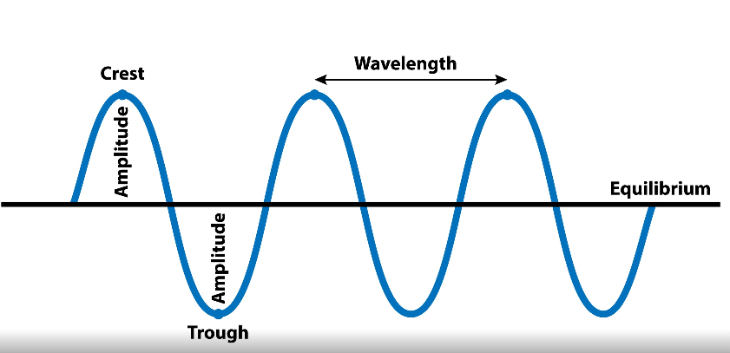

Fig 1

With a ruler measure the Wavelength, frequency(assuming all distance shown above in 1second) and amplitude for the above wave

|  |  |
| --- | --- |
| Question | Answer |
| What is the amplitude of the wave |  |
| What is the frequency for above wave ? |  |
| What is the wavelength of above wave ? |  |
| How many waves are there ? |  |

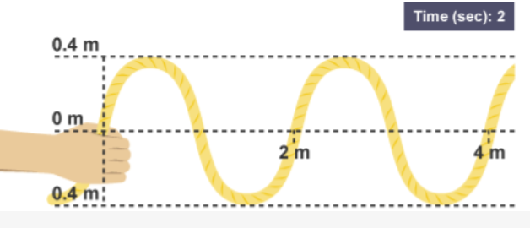

Fig 2 Transverse Waves

Looking at Fig1 for Transverse Wave answer the following

|  |  |
| --- | --- |
| Question | Answer |
| How many waves are there in Fig 1 |  |
| What is the amplitude of the wave |  |
| What is the frequency for above wave ? |  |
| What is the wavelength of above wave ? |  |